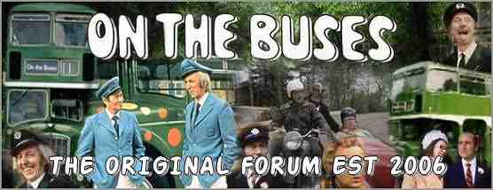

You are cordially invited to attend the 2012 On The Buses Event: A Fresh Start

On Saturday the 30th of June 2012 at The Fairway Hall, Borehamwood at 9.30 am
Ticket Owner …………. ………………..
Ticket Type: ………….
Ticket No: …...

